|  |  |  |
| --- | --- | --- |
| **Discern**  By the end of this unit of study, pupils will be able to talk and think creatively and critically about what they have studied, for example, through: | | |
|  | Responding to a variety of artistic ways in which the Jesse tree is portrayed. Suggest reasons for the artist’s choices and give reasons for their personal preference. |  |
|  | Talking about the type of king they think Jesus would be and give reasons for their answers. |  |
|  | Responding to a variety of artistic ways in Christ the King portrayed. Suggest reasons for the artist’s choices, give reasons for their personal preference and compare their ideas with others. |  |
| **Respond**  During this unit of study, pupils will be invited to respond to their learning, for example by: | | |
|  | Reflecting on how Elijah and John the Baptist’s words speak to people today. |  |
|  | Reflecting on what it means to be a good leader and talk to others about their ideas. (RVE) |  |

|  |  |  |
| --- | --- | --- |
| **Understand**  By the end of this unit of study, pupils will be able to: | | |
|  | Describe what a prophet is drawing on Elijah and John the Baptist as examples. |  |
|  | Show some understanding of the cultural and religious context of Elijah’s time and why people needed to be reminded of God’s covenant. |  |
|  | Compare the description of John the Baptist in Mark and Matthew’s accounts and describe the beliefs about John the Baptist the gospel writers show. |  |
|  | Make links with the words of Isaiah, the preaching of John the Baptist, and the season of Advent. |  |
|  | Know that the feast of Christ the King marks the end of the Church’s year and describe what is celebrated. |  |
|  | Makes links with the ancestry of Jesus and the Jesse tree. |  |

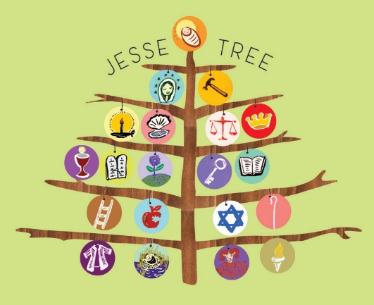

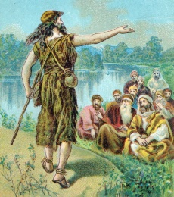

**Key Vocabulary**

Advent prophet Elijah

John the Baptist

Jesse tree Christ the King