St George’s Sticky Facts and Disciplinary Skills Assessment Sheet 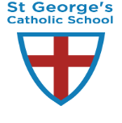
Year 1 – History Curriculum – Local Study and Toys
1 – WT 2 – ARE 3 - GDS
Name | Historical Terms – How long ago was the Victorian Era ? | Name things that have changed and things that have stayed the same in Minehead or Weston. | Cause and Consequence – why have they changed ? | Continuity and Change – compare changes in toys through observation and communicate this. | Name traditional playground games. | Explain that in the 19th Century, England was a Christian country and lots of people learned about and believed in The Bible. | Know there were big divides between rich and poor in the Victorian era and this affected the toys they could buy.

