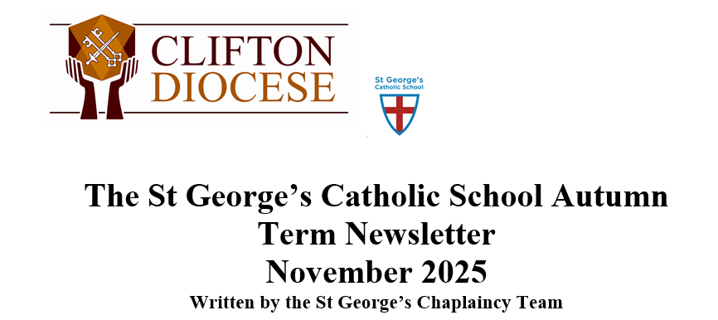

Dear Parish Family,
What a wonderful time we have had at St. George’s Catholic School celebrating our Harvest Festival! This special event gave our school community the chance to pause, reflect, and say a big “Thank you, God!” for all the gifts we receive from His creation.
Every class took part in the celebrations in their own special way. Some children wrote poems, some sang songs, and others created beautiful artwork, all sharing messages of love and gratitude. It was amazing to see the children expressing their thankfulness so creatively and thoughtfully.
Our celebration wasn’t just about saying thank you with words and pictures. The children also brought in food donations from home to share with those in need. These donations, collected from every year group, were sent to local food banks, helping our wider community and living out the message of kindness and generosity that Jesus teaches us.
It was inspiring to see our school family come together to celebrate, create, and give. We hope that through events like this, our children continue to grow in their understanding of gratitude, generosity, and love for God and others.

Caring for God’s Creation – Our Energy Walks
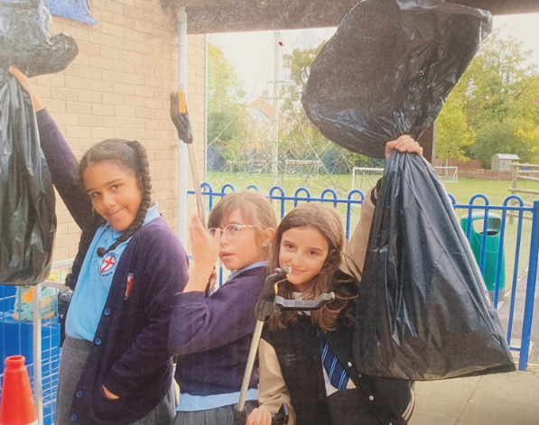
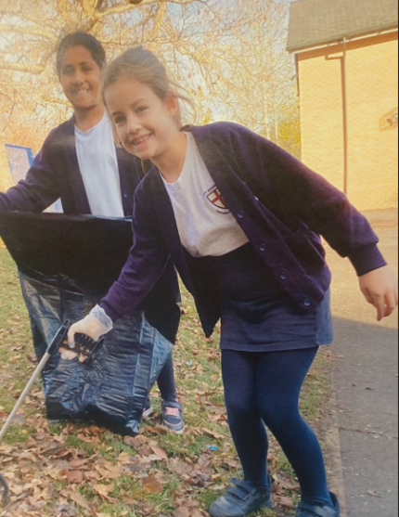

At the St. George’s Catholic School, we are helping us look after God’s wonderful world. Following God’s message that we are called to be stewards of His creation, our Year 4, 5, and 6 chaplains have been leading Energy Walks every day!
During the Energy Walks, chaplains visit every classroom at break and lunchtime to make sure that lights are switched off when they are not needed. They carefully sign a sheet for each class, which helps us keep track and see how well we are doing. These sheets show that together, we are making a difference by saving energy and caring for the planet God gave us.
It’s wonderful to see our older children taking on this responsibility with such care and enthusiasm. They are showing all of us how small actions, like turning off lights, can help God’s creation and protect the Earth for future generations.
By taking part in Energy Walks, we are not just saving energy – we are living our faith through action, caring for our world as God asks us to.
In addition, once a month, children work together to litter pick around the school grounds, keeping our playground and school environment clean and beautiful. By taking part in these activities, our children are showing that caring for God’s creation is about both energy and our surroundings, living out our faith through practical action.

Big Congratulations to Our New Leader of Faith!
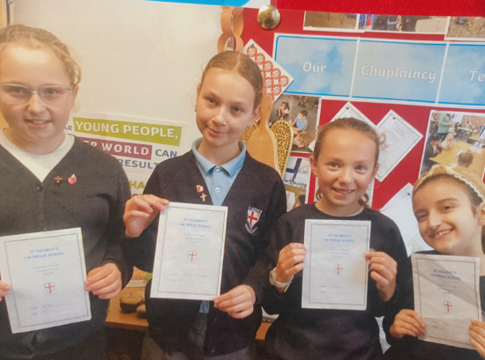
A huge well done to our new Leader of Faith, who has been awarded the Bronze Level for their commitment, dedication, and excellent knowledge of Gospel values. Their hard work and faith-filled example are truly inspiring!
They are already working hard towards achieving the Silver Level and are excited to train and guide our younger chaplains in their new mission. We can’t wait to see all the wonderful ways they will continue to lead and share God’s love throughout our school.

Sharing Our Prayers at Mass
Our Year 5 and Year 6 chaplains have been working hard to write Bidding Prayers for the classes attending Wednesday Masses. We are so proud that the prayers created by our learners are being read aloud during Mass by children from all classes helping everyone in our school and parish to come together in prayer and reflection.

What’s to Come – Preparing for the Messiah
As we move into December, we are getting ready for the coming of the Messiah. At this special time, we remember that Jesus was always on the side of the poor and vulnerable, and we try to follow in His footsteps every day.
Our learners will be preparing Christmas cards and decorations to share with the residents of Ellisfields Court, and we will celebrate together, singing carols by our school choir and exchanging small gifts. We are also excited to welcome parishioners from Nunsfield Court, who will join us for a special visit and lunch served by the chaplaincy team.
Back at school, the younger pupils of St. George’s are already starting to practise for their Nativity play, and we cannot wait to see their wonderful performance soon!

Parish Coffee Morning

We would like to warmly welcome all parish members to join us for coffee and tea on Wednesday 7th January at St. George’s Catholic School, following the morning Mass at St. George’s Catholic Church.
We are looking forward to seeing everyone and sharing a lovely time together as a parish community!


