|  |  |  |
| --- | --- | --- |
| **Discern**  By the end of this unit of study, pupils will be able to talk and think creatively and critically about what they have studied, for example, through: | | |
| D4.3.1 | Thinking about and discussing answers to Jesus’ question, ‘Who do you say I am?’, consider the response of Peter and the response of Christians today. |  |
| D4.3.2 | Considering the claim ‘The miracles that Jesus worked were signs that the Kingdom of God was beginning. They expressed his love for humankind and reaffirmed his mission’ (YOUCAT 91), expressing a point of view, supported by relevant reasons, in response to this statement. |  |
| **Respond**  During this unit of study, pupils will be invited to respond to their learning, for example by: | | |
| R4.3.1 | Reflecting on those that society excludes today and consider how they could show love for these people as Jesus did. (RVE) |  |
| R4.3.2 | Considering how Jesus serves others and discussing how Christians can follow this example today. What could this mean for their lives and the lives of their local communities? (RVE) |  |

|  |  |  |
| --- | --- | --- |
| **Understand**  By the end of this unit of study, pupils will be able to: | | |
| U4.3.1 | Show understanding of why some people gave Jesus the title ‘Christ’ (the anointed one) by making links with the Scripture studied. |  |
| U4.3.2 | Make links between Jesus’ speech to John the Baptist’s followers and signs that he is the Messiah. |  |
| U4.3.3 | Show understanding of the belief that Jesus reveals the kind of messiah he is by showing that God’s Kingdom includes those who are excluded by society, making relevant links to the Scripture studied. |  |
| U4.3.4 | Using some religious vocabulary, describe the Sacrament of Reconciliation and the Sacrament of the Sick. |  |
| U4.3.5 | Make relevant links between the belief in that Jesus is the Messiah and the Nicene Creed (specifically Articles 2-4) and suggest why Catholics say this prayer. |  |
| U4.3.6 | Describe the work of a person or organisation who has been inspired by Jesus to work with those marginalised by societal attitudes to illness making links with the virtues of faith, hope, and love. (RVE) |  |



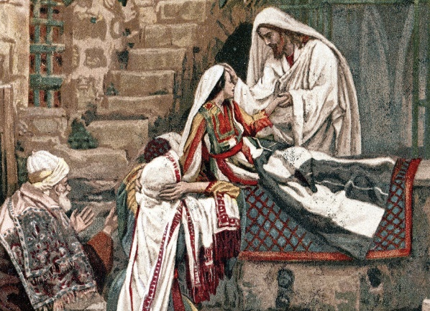

**Key Vocabulary**

Messiah Christ marginalised

Nicene Creed incarnation

kingdom sacrament of the sick