St George’s: EYFS Long Term Curriculum
Intent: At St George’s Catholic Primary School we encourage our children to ‘Grow in Mind, Body and Spirit’ and offer a curriculum rich in wonder and memorable experiences. We work hard to provide a stimulating environment that provides exciting opportunities, promotes challenge, exploration, adventure and a real love of learning.
It is our intent that all children develop physically, verbally, cognitively and emotionally in an environment which values all cultures, communities and people. We aim for our children to be confident and independent, to believe in themselves and interact positively with others. We understand that play is an integral part of learning and this is at the heart of our early years’ curriculum. We believe that the correct mix of teaching, adult directed activities and child-initiated play ensures the best outcomes for pupils. Warm and positive relationships between staff and children, consistent routines and strong relationships with parents are key.
We recognise the crucial role that early year’s education has to play in providing firm foundations upon which the rest of a child’s education is successfully based.
Implementation: At St George’s we meet the welfare requirements laid down in the Statutory Framework for the Early Years Foundation Stage and actively safeguard and promote the welfare of all our children.
We prioritise creating a ‘language rich’ environment for all children by using songs, nursery rhymes and stories, and through ensuring time for quality interactions between adults and between peers. Staff ensure that interactions are positive and progressive, allowing children to flourish and become confident communicators. Many of our children start school learning English as a second language and some have communication and language difficulties. We identify children that need extra support to keep up and use interventions such as Talking Groups and NELI to narrow the gap. Children are encouraged to become early readers through enjoyment of books and the systematic teaching of phonics through the Little Wandle phonics programme. The children learn nursery rhymes/poems and develop their mathematical thinking through direct teaching and exploration. We want our children to become confident mathematicians who can apply what they have learnt to real life experiences.
Our learning environment is adaptable in order to reflect children's interests and progression. The children are supported to learn to work together, manage their feelings and ask questions through skilled adult facilitated play. The children have access to outdoors which enables them to strengthen their core muscles through physical play and they have the opportunity to participate in exploratory and sensory experiences which include access to the sandpit, water tray and also our Nature Area. The curriculum is taught through themes/topics which are enriched with classroom enhancements, trips and visitors. Topics are supported by quality key texts. These are chosen carefully to encourage children's speech, language and communication development. All planning, however, is flexible and responsive to children’s needs so plans can be changed and adapted depending on the children’s interests and progression.
We understand the importance of parental engagement and believe that our parents have a crucial role to play in their children's education. We work hard to create strong partnerships between home and school. Parents receive information each half term to inform them of what their child is learning and the children will take home a book that has knowledge organisers/vocabulary sheets that can be used to support their child at home. There will be meetings to support parents in understanding how we teach early reading, writing and Maths. We share their child’s Learning Journey with them and encourage parents to share experiences and learning from home.
As part of the learning and teaching process, children are assessed in relation to their progress towards the Early Learning Goals. These judgements are made based on accumulative observations and in-depth knowledge of the children acquired through ongoing assessment. These ongoing assessments are used to inform planning and next steps in teaching and learning for all children throughout the year.

(This table will be added to/amended throughout the year depending on needs of the children)

 | Autumn 1 | Autumn 2 | Spring 1 | Spring 2 | Summer 1 | Summer 2
Main Theme (but not limited to..) | Here We Are | Celebrations | Keep on Moving | Ready Steady Grow | All Creatures Great & Small | To the Rescue!
Possible ideas  /lines of enquiry  These mini ideas  within the themes may change or be replaced depending on child  interest or  fascination. | All about me My family  Where I live  Feelings  Senses  Harvest | Autumn  Birthdays  Fireworks/ Bonfire Night  Hanukkah  Christmas | Winter  Chinese New Year  Transport- including Emelia Earhart | Spring  Growing- including how we grow  Keeping heathy  Holi  Easter | Minibeasts  Under the Sea Rainforests/  Jungles  (making comparisons to where we live) | Superheroes  People who help us/ Occupations  Summer  Moving on
Experiences | Whole School Wow Focus  Around school walk  Church visit  Harvest Festival | Whole School Wow Focus  Autumn walk  Christmas Stay and Play  Nativity play  End of term Mass | Whole School Wow Focus  Winter Hunt | Whole School Wow Focus  Easter Stay and Play  Spring walk  PCSO visit  Stations of the Cross  End of term Mass | Whole School Wow Focus  Beginning of term Mass (at church)  Minibeast visitor | Whole School Wow Focus  Dentist visit  Class trip  End of Reception celebrations  End of term Mass
Main Texts | 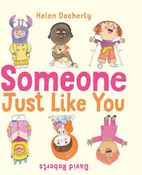  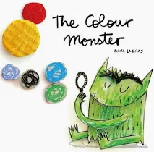  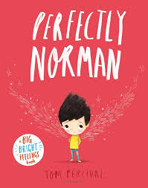 | Literacy Tree- Where the Wild Things are  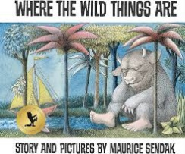  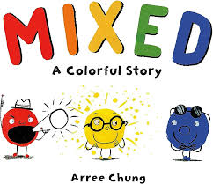  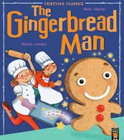 | 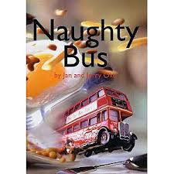  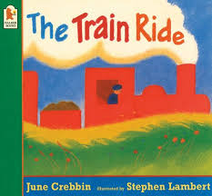  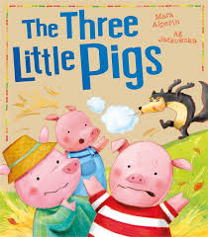 | Literacy Tree- The Tiny Seed  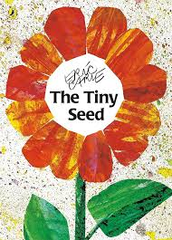  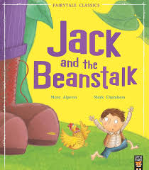  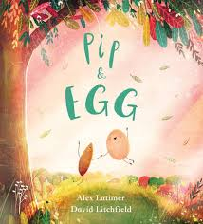 | Literacy Tree- Oi Frog  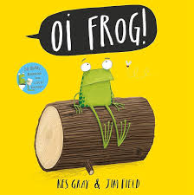 | 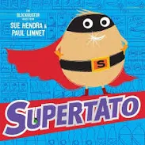  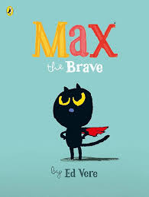  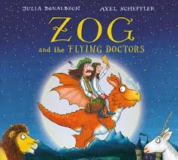

Communication, Language and Literacy | When pupils start school in September, they will have a NELI assessment and from there communication and language support interventions will be put in place to support key skills. Little Wandle Phonics will begin as soon as the children are in full time. Alongside Phonics, pupils will have reading practise sessions three times per week with a trained member of staff. Songs and Rhymes will be shared daily with pupils along with daily story time to foster a love of reading. Staff will focus on high quality interactions within play. Pupils will take part in Drawing club three times per week with the teacher. This session will enable them to learn new vocabulary and use their phonics to learn to write words and then sentences.

PSED  SCARF units (S) are chosen when appropriate  Themes chosen in response to children’s needs at the time. | Settling in  All About Me (S)  I am special  My feelings | Valuing difference (S)  Firework safety  Mindset characters- Resilience the Mouse etc | Keeping safe in Winter  Keeping safe online (S)  Friendship and working together  Road safety | Growing and changing- life stages (S)  What’s safe to go on and in my body? (S)  Keeping Healthy | Rights and Respect (S)  Caring for our world (S)  Looking after money (S) | Journey in Love- Diocese RSE planning  Being my Best (S)  Superhero values  Moving on

Physical Development | Develop the overall body strength, co-ordination, balance, and agility needed to engage successfully with future physical education sessions and other physical disciplines including dance, gymnastics, sport, and swimming.  Develop their small motor skills so that they can use a range of tools competently, safely, and confidently. Suggested  tools: pencils for drawing and writing, paintbrushes, scissors, knives, forks, and spoon.  Use their core muscle strength to achieve a good posture when sitting at a table or sitting on the floor.  Develop overall body-strength, balance, co-ordination, and agility.

 | Squiggle While You Wiggle  Up and Down  The Wiggle  Circles  Funky Fingers  PE/swimming with JC  Further develop the skills they need to  manage the school day successfully: lining up and queuing, mealtimes,  personal hygiene  Develop fine motor skills- holding pencil  correctly, using  scissors etc | Squiggle While You Wiggle  The hump  The Precursive Spiral  A Gentle Wave  Funky Fingers  PE/swimming with JC  Revise and refine  the fundamental  movement skills  they have already  acquired: rolling,  crawling, walking,  jumping, running,  hopping, skipping,  climbing. Develop fine motor skills- holding pencil correctly, using scissors etc | Squiggle While You Wiggle  Laid down and straight 8  Straight Line  Funky Fingers  PE/swimming with JC  Further develop  and refine a range of ball skills including throwing, catching,  kicking, passing,  batting, and aiming.  Develop confidence,  competence, precision, and accuracy when  engaging in activities that involve a ball. | SWW and Funky Fingers will carry on where necessary  PE/swimming with JC  Know and talk  about the different factors that support their overall health and wellbeing: regular physical activity, healthy eating, toothbrushing,  sensible amounts of ‘screen time’, having a good sleep routine, | PE/swimming with JC  Combine different  movements with  ease and fluency  Develop the  foundations of a  handwriting style  which is fast,  accurate and  efficient. | PE/swimming with JC  Confidently and  safely use a range  of large and small  apparatus indoors  and outside and in a group.  Revisit keeping healthy, including taking care of our teeth. Being a safe  pedestrian.
RE  See Diocese planning | Creation and Covenant | Prophecy and Promise | Galilee to Jerusalem | Desert to Garden | To the Ends of the Earth | Dialogue and Encounter
Understanding The World experiences  Not limited to just  these. These will be regularly reviewed depending on the  cohort and will be  flexible to react to  child interest and  events. | Set up timeline for year events.  Tree photograph every month.  What am I like?  Who is in my family?  Where do I live?  What is it like?  Using world map to explore where our families live around the world.  My body/senses, including sound.  Why/how do some people celebrate Harvest?  Foods grown around the world | Birthdays in the past  Autumn changes- exploring leaves and other found objects.  Learn about hibernation and migration.  Why/how do some people celebrate Bonfire Night, Diwali, Hanukkah and Christmas?  Colours  Explore rainbows  Making Gingerbread men and noticing how the mixture changes in the oven. | Changes in the seasons- Winter.  Comparing cold/hot places  Floating and Sinking- boats  How do people travel? Making comparisons.  Transport in the past.  Learning about Emelia Earhart and George Stephenson.  Why/how do some people celebrate Lunar and Chinese New Year? | Changes in the seasons- Spring  Spring walk- including exploring simple maps of school area  How do things grow? Including looking at changes in themselves.  Planting potatoes and beans.  How do some people celebrate Holi and Easter?  Healthy food plate and Fruit tasting  Teeth Brushing | Minibeasts- key features and habitats  Life cycle of a frog  Learning about how to help to save our oceans.  Finding out about some creatures that live in the sea/rainforests. Making comparisons.  Using a map to find where they are.  Learning about Eugenie Clark and David Attenborough. | Learning about different occupations/ People who help us in the community.  Exploring Ice- How to melt it quickly to save the super veggies  Exploring Materials- Best Material for a cape.  Changes in the seasons- Summer  Investigating shadows
Expressive Arts and Design experiences  Not limited to just  these. These will be regularly reviewed depending on the  cohort and will be  flexible to react to  child interest and  events. | Self-Portraits  Colour & colour mixing  Music- Singing songs together. Action rhymes/nursery rhymes  Cutting skills focus  Charanga- Me  Role play area- Home corner and then changing to reflect interests of children. | Observational drawings of Autumnal objects.  Artists: Kandinsky and Pacita Abad linked to work on ‘The Dot’  Making Gingerbread men  Clay- diwa lamps  Charanga- My Stories | Kerala Mural Paintings  Design and make a boat  Shades of colour  Charanga- Everyone | Artist: Olga Boznańska explore flower paintings  Easter nests  Clay- flower pots  Charanga- Our World  Exploring toys with winding mechanisms. | Sculpture- liked to work of Alexander Calder and Robert Smithson  Collage- sea creatures.  Charanga- Big Bear Funk | Cooking potatoes- using a peeler and masher.  Printing- potatoes and other objects  Book- Katy and the British Artists  Charanga- Reflect, Rewind & Replay
Technology/  Computing  Referring to Barefoot Computing: Computational Thinking: Tinkering, Creating, Collaboration, Persevering, Logic, Pattern, Abstraction, Algorithms & Decomposition.  ELIM strands:  Technology in Our Lives  Multimedia  Programming  Handling Data | E-Safety  Using a digital camera and iPad to take photos (themselves and our world)  Google Earth  Technology walk  Video- I like…….  Chrome books- Simple City  Google Classroom | E-Safety  Code a Pillar  Mapping the school- taking photos, using directions  Chrome Books- 2Paint and 2Publish- creating a border for Christmas Present | E-Safety- including Internet Safety Day  Digital microscope  Talking tins/video- story telling  Bee-Bot  Espresso- finding out about hot/cold places | E-Safety  Chrome Books- 2Paint and name  Digital camera- signs of Spring | E-Safety  2 Publish- minibeast and caption  Using internet to find out information about animals. | E-Safety  Bee-Bot  2Simple music toolkit- creating own music  Espresso- Occupations
Maths- | We use Mastering Number and White Rose as a basis. Pupils will take part in four weekly maths lessons along with planned opportunities both indoors and outdoors to practise key skills. Assessment will be used to adapt the programme to meet the individual needs. (See separate Maths Overview)
Impact: Our curriculum and its delivery ensure that children make good progress from their individual starting points. During their time with us children make rapid progress towards the national expectation for a good level of development at the end of the year. Pupils also make good progress toward their age-related expectations both academically and socially, developing a sense of themselves before transitioning into Year One.
Children develop their characteristics of learning and are able to apply their knowledge to a range of situations making links and explaining their ideas and understanding. Children are confident to take risks and discuss their successes and failures with peers and adults, drawing on their experiences to improve or adjust what they are doing.
We believe our high standards are due to our carefully planned environment, enriched play-based curriculum, quality first teaching and the rigour of assessment.

