|  |  |  |
| --- | --- | --- |
| **Discern**  By the end of this unit of study, pupils will be able to talk and think creatively and critically about what they have studied, for example, through: | | |
| D4.6.1 | Looking at how a range of artists show St Paul’s encounter with Jesus and discuss which one they prefer, giving relevant reasons for their opinion. |  |
| D4.6.2 | Exploring some examples of art or music from a different Catholic community, for example, icons of the Coptic Church, and asking questions about what they have noticed. (RVE) |  |
| D4.6.3 | Listening to the stories and experiences of others from different Christian communities in the class and the wider community and asking questions about their beliefs, worship, or life. (RVE) |  |
| **Respond**  During this unit of study, pupils will be invited to respond to their learning, for example by: | | |
| R4.6.1 | Discussing the meaning of what they have learned for their own lives. (RVE) |  |
| R4.6.2 | Talking, asking, and answering questions with others about their beliefs, experiences, and feelings, recognising the ways in which this could change the way they live and the relationships in their local communities. (RVE) |  |
| R4.6.3 | Reflecting on what they can learn from the stories of families from different Christian traditions or who follow different liturgical traditions. (RVE) |  |

|  |  |  |
| --- | --- | --- |
| **Understand**  By the end of this unit of study, pupils will be able to: | | |
| U4.6.1 | Describe some facts about the life of St Paul and explain why he is an important figure for  Christians. (RVE) |  |
| U4.6.2 | Make links between Cor 13:1-7, 13 and the theological virtues. |  |
| U4.6.3 | Recount some facts about a different liturgical rite within the Catholic Church. |  |
| U4.6.4 | Recognise some reasons why different liturgical traditions arose in different parts of the world. |  |
| U4.6.5 | Describe some ways Christians in their local area work together for the benefit of the whole community (or the common good). (RVE) |  |
| U4.6.6 | Describe the five pillars of Islam and why they are an important part of Islamic faith and religious practice for British Muslims today. (RVE) |  |

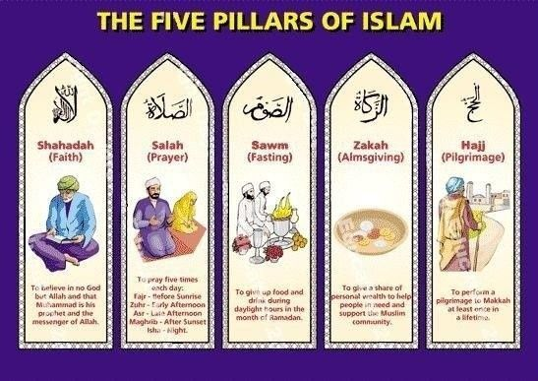

**Key Vocabulary**

Damascus Liturgy rite

Christian Islam

Five Pillars of Islam Hajj

Shahada Salah Sawm

Zakat Common Good

