|  |  |  |
| --- | --- | --- |
| **Discern**  By the end of this unit of study, pupils will be able to talk and think creatively and critically about what they have studied, for example, through: | | |
| D4.4.1 | Considering why St Peter might have turned away from Jesus and how that made him feel making connections with when they have let people down or broken a promise. |  |
| D4.4.2 | Expressing a point of view about the difference between the people who are like sheep and the people who are like goats in the Judgement of Nations. |  |
| D4.4.3 | Making connections between being a Christian and choosing to live out the ‘Works of Mercy’. (RVE) |  |
| **Respond**  During this unit of study, pupils will be invited to respond to their learning, for example by: | | |
| R4.4.1 | Reflecting on how the life and work of a person or organisation (historical or contemporary) lives out the works of mercy and/or the love for those oppressed by poverty and the inspiration they offer for their life. (RVE) |  |
| R4.4.2 | Reflecting on what it is they need to change about themselves during Lent to be better people and discuss how focusing on one of the acts of mercy could help with this, for example, caring for the most vulnerable in their communities. (RVE) |  |
| R4.4.3 | Considering how their own lives and the future of the communities to which they belong could be transformed by what they have learned about forgiveness. (RVE) |  |

|  |  |  |
| --- | --- | --- |
| **Understand**  By the end of this unit of study, pupils will be able to: | | |
| U4.4.1 | Retell, with increasing detail, the parable of the prodigal son, and make simple connections with Christian beliefs about God’s mercy and forgiveness. |  |
| U4.4.2 | Make simple connections with the Judgement of Nations parable and the Christian belief that helping others is part of loving God. |  |
| U4.4.3 | Correctly sequence the events of Holy Week, describing some of the different reactions to Jesus during the events of Holy Week and how they speak to Christians today. |  |
| U4.4.4 | Retell the story of St Peter during Holy Week. |  |
| U4.4.5 | Correctly use developing specialist vocabulary to name and describe the corporal works of mercy, making links with the Judgements of the Nations parable. |  |
| U4.4.6 | Make simple connections between belonging to the Church and living out the ‘Works of Mercy’ in support of those in need (for example, giving alms in Lent or praying for someone who is sad). |  |

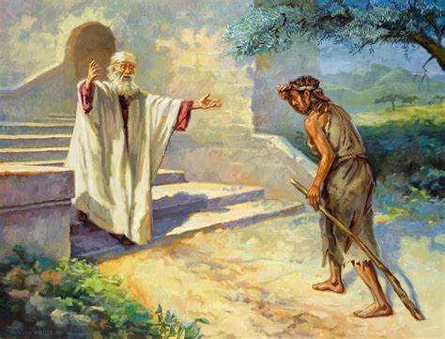

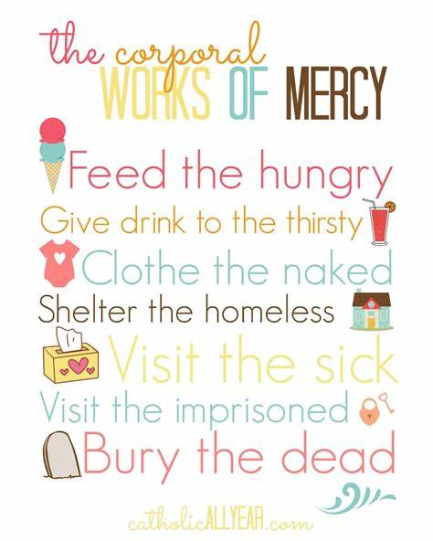

**Key Vocabulary**

Lent Holy Week parable

sin forgiveness mercy